

abb-1 map

Project Report



DETAILS OF THE TEAM

(4 Members)

1. *RHYTHM SRIVASTAVA 21103234 – B11*

2. *SRISHTI* GARG 21103227 ***–*** *B11*

3. *KAMAL GARG 21103231- B11*

*4.HIMANSHU DIXIT 21103262 - B11*

Submitted To :-

Ms. Sherry Garg

**ACKNOWLEDGEMENT**

We have taken a lot of effort into this project. However, completing this project would not have been possible without the support and guidance of a lot of individuals. We would like to extend our sincere thanks to all of them.

We are highly indebted to Ms. Sherry Garg Mam for her guidance and supervision. We would like to thank her for providing the necessary information and resources for this project.

We would like to express our gratitude towards our parents and our friends for their kind co-operation and encouragement which help us a lot in completing this project.

Our thanks and appreciations also go to our colleagues in developing the project. Thank you to all the people who have willingly helped us out with their abilities.

**ABSTRACT OF THE PROJECT**

This C++ project made by us is a saviour to all the freshers of our college Jaypee Institute Of Information Technology, Noida, Sector-62. Searching for classes becomes a hustle for them in between the change overs due to which they get late for their classes. So we have attempted to listen to their cries by making a project which takes the input of the class at which they are currently present (source) and the class to which they want to move to (destination) and they will get the detailed shortest path as a series of identifiable points to reach the class they wanted to move to as the output. It is as simple as that. This program is a map of academic building ABB-1 of JIIT. It covers all the three floors of this building along with the passages, staircases, wing entries and exits. ABB-1 map has been made with the objective of making the system reliable,easier,fast and more informative. This C++ code mainly makes use of graphs along with a famous shortest path algorithm Dijsktra’s.

*TOPICS USED IN THIS PROJECT*

* Graphs
* Classes
* If Else statements
* Functions
* Strings
* Array
* Switch case
* Loops
* Dijkstra’s Algorithm

**REFERENCE MAP**

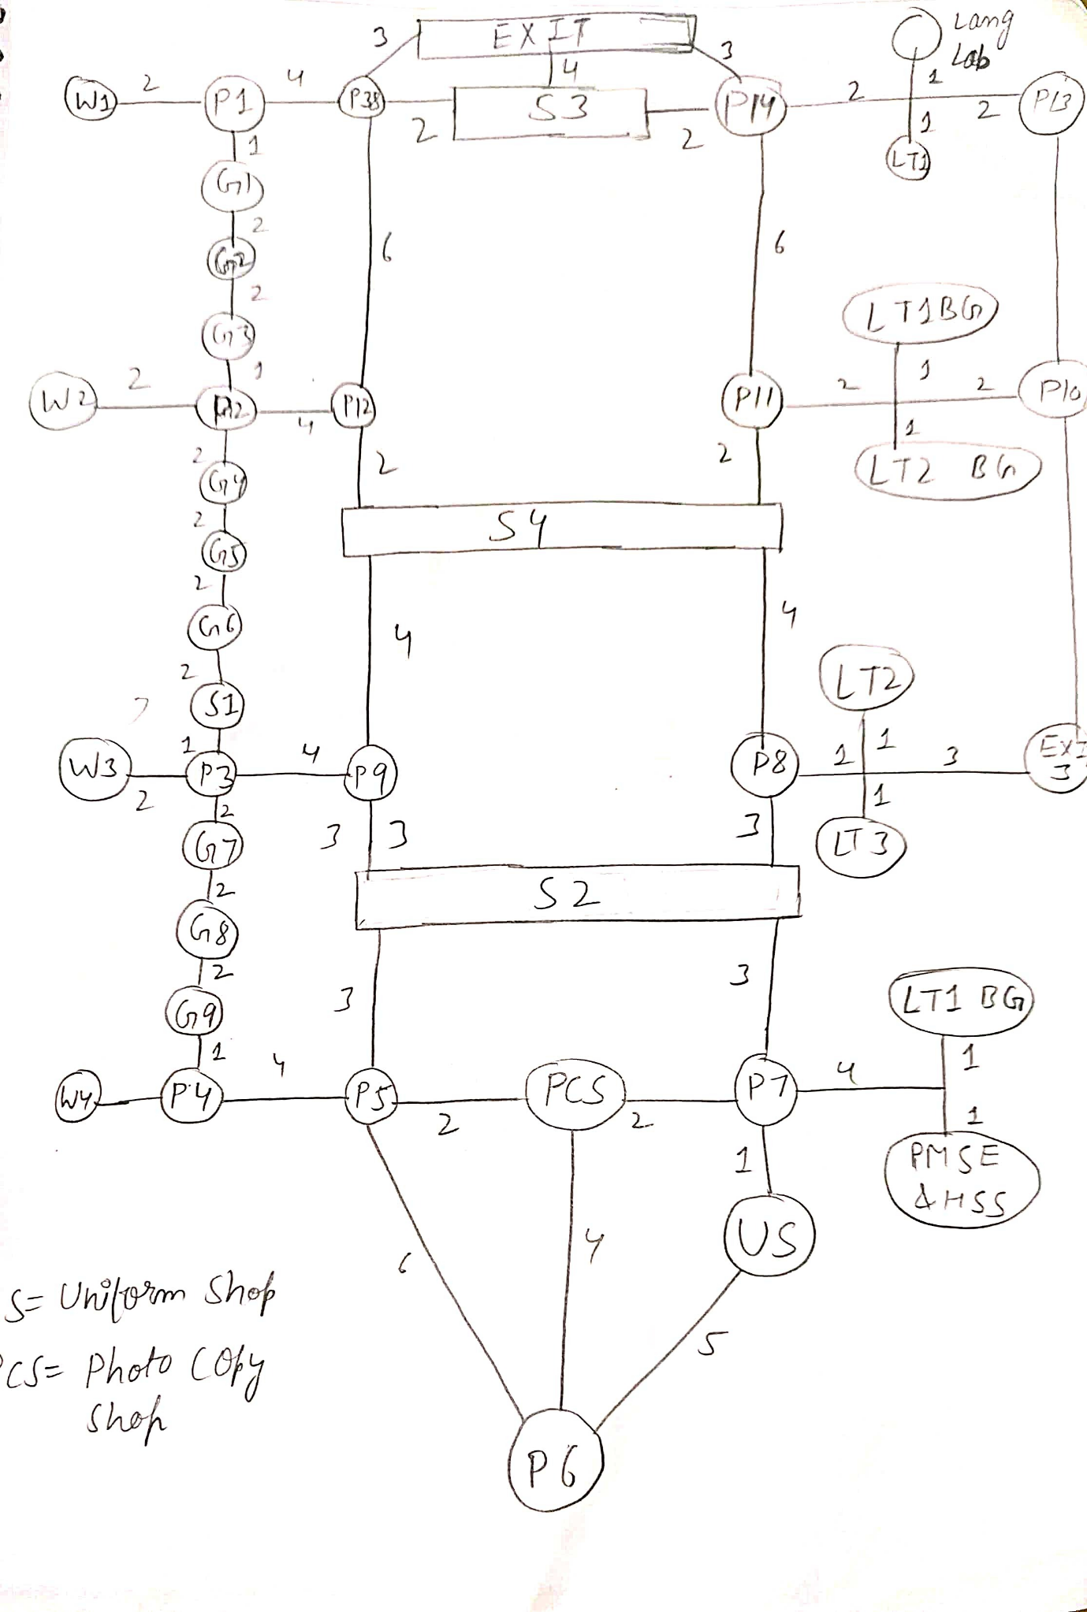**Ground FLOOR:**

**FIRST FLOOR:**

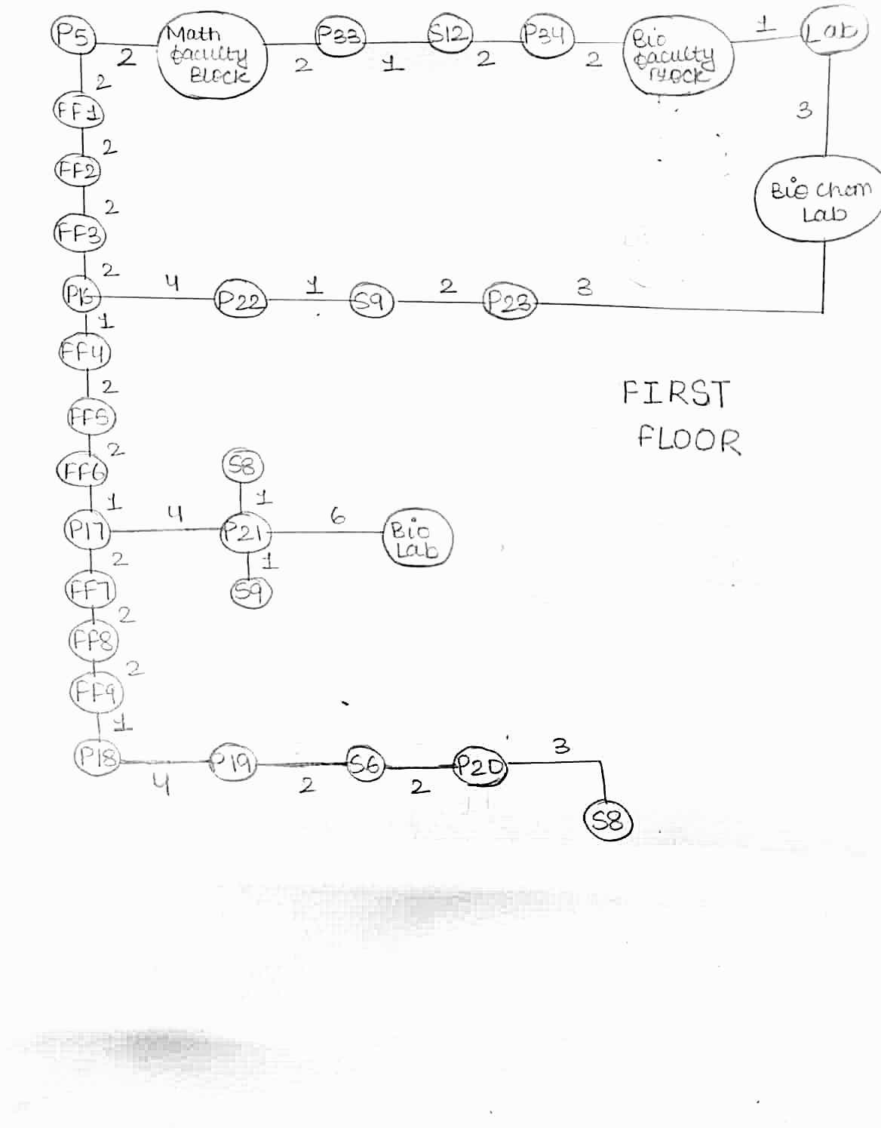

**SECOND FLOOR:**

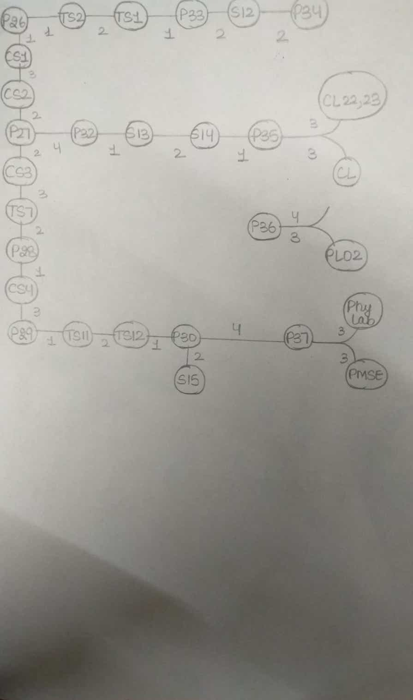

**SOURCE CODE**

//---------------------------------------------------------------------------------------------------------

// header files used in project

//---------------------------------------------------------------------------------------------------------

#include <iostream>

#include <time.h>

#include <conio.h>

#include <climits>

#include <cstring>

using namespace std;

#define v 112

int arr[v][v]{0};

void help(int u, int x, int d)

{

    arr[u][x] = d;

    arr[x][u] = d;

}

template <typename T>

class vector

{

    T *arr;

    // capacity of the vector

    int capacity;

    // current is the number of elements

    int current;

public:

    // constructor

    vector()

    {

        arr = new T[1];

        capacity = 1;

        current = 0;

    }

    vector(int c, int val = 0)

    {

        arr = new T[c];

        for (int i = 0; i < c; i++)

        {

            arr[i] = val;

        }

        capacity = c;

        current = 0;

    }

    // destructor

    ~vector()

    {

        delete[] arr;

    }

    void push(T data)

    {

        /* if the number of elements is equal to the

        capacity, that means we don't have space to

        accommodate more elements. We need to double the

        capacity */

        if (current == capacity)

        {

            T *temp = new T[2 * capacity];

            // copying old array elements to new array

            for (int i = 0; i < capacity; i++)

            {

                temp[i] = arr[i];

            }

            // deleting previous array

            delete[] arr;

            capacity *= 2;

            arr = temp;

        }

        // Inserting data

        arr[current] = data;

        current++;

    }

    void push(T data, int index)

    {

        if (index == capacity)

            push(data);

        else

            arr[index] = data;

    }

    // function to extract element at any index

    T get(int index)

    {

        if (index < current)

            return arr[index];

    }

    // function to delete last element

    void pop()

    {

        current--;

    }

    // function to get size of the vector

    int size()

    {

        return current;

    }

    // function to get capacity of the vector

    int getcapacity()

    {

        return capacity;

    }

    // function to print array elements

    void print()

    {

        for (int i = 0; i < current; i++)

        {

            cout << arr[i] << " ";

        }

        cout << endl;

    }

    T &operator[](int i)

    {

        return arr[i];

    }

};

vector<int> dist(v, INT_MAX);

vector<int> parents(v);

string names[] = {

    "W1",

    "P1",

    "G1",

    "G2",

    "G3",

    "P2",

    "G4",

    "G5",

    "G6",

    "S1",

    "P3",

    "G7",

    "G8",

    "G9",

    "P4",

    "P5",

    "P6",

    "Uniform Shop",

    "P7",

    "Photo Copy Shop",

    "PMSE & HSS",

    "LT3 BG",

    "S2",

    "EXIT 3",

    "LT3",

    "LT2",

    "P8",

    "P9",

    "P10",

    "LT2 BG",

    "P11",

    "LT1 BG",

    "P12",

    "LT1",

    "P13",

    "LANG LAB",

    "P14",

    "S3",

    "EXIT",

    "S4",

    "P15",

    "FF1",

    "FF2",

    "FF3",

    "P16",

    "FF4",

    "FF5",

    "FF6",

    "S5",

    "P17",

    "FF7",

    "FF8",

    "FF9",

    "P18",

    "P19",

    "S6",

    "P20",

    "S7",

    "BIO LAB",

    "P21",

    "S8",

    "BIO LAB",

    "P22",

    "S9",

    "P23",

    "BIO CHEM LAB",

    "BIO CHEM LAB",

    "BIO FACULTY",

    "P24",

    "S10",

    "P25",

    "MATH FACULTY",

    "P26",

    "CS1",

    "CS2",

    "P27",

    "CS3",

    "TS7",

    "P28",

    "CS4",

    "P29",

    "TS11",

    "TS12",

    "P30",

    "TS10",

    "TS9",

    "P31",

    "S11",

    "TS8",

    "P32",

    "TS2",

    "TS1",

    "P33",

    "S12",

    "P34",

    "TnP",

    "S13",

    "S14",

    "P35",

    "CL22 AND CL23",

    "NCL1",

    "NCL2",

    "P36",

    "PL02",

    "PL01",

    "P37",

    "PMSE",

    "S15",

    "P38",

    "W2",

    "W3",

    "W4",

};

static int a = 0;

void printPath(int currentVertex, vector<int> &parents)

{

    // Base case : Source node has

    // been processed

    if (currentVertex == -1)

    {

        return;

    }

    printPath(parents[currentVertex], parents);

    if (a++ > 0)

    {

        cout << "--->";

    }

    cout << names[currentVertex] << " ";

}

// A utility function to print

// the constructed distances

// array and shortest paths

int printSolution(int startVertex, vector<int> &distances,

                  vector<int> &parents, int d, int choice)

{

    if (choice == 1)

    {

        cout << "\n\n\t\t\tSource\t\tDestination\t\tDistance";

        cout << "\n\n\t\t\t------------------------------------------------";

    }

    else if (choice == 2)

    {

        cout << "\n\n\t\t\tSource\t\tDestination\t\tPath";

        cout << "\n\n\t\t\t--------------------------------------------";

    }

    else if (choice == 3)

    {

        cout << "\n\n\t\t\tSource\t\tDestination\t\tDistance\t\tPath";

        cout << "\n\n\t\t\t--------------------------------------------------------------------";

    }

    for (int vertexIndex = 0; vertexIndex < v;

         vertexIndex++)

    {

        if (vertexIndex != startVertex && vertexIndex == d)

        {

            cout << "\n\n\t\t\t" << names[startVertex] << " \t\t ";

            cout << names[vertexIndex] << " \t\t\t   ";

            return distances[vertexIndex];

        }

    }

    return 0;

}

int dijkstra(int graph[][v], int s, int d, int choice)

{

    dist[s] = 0;

    parents[s] = -1;

    vector<bool> fin(v, 0);

    for (int j = 0; j < v - 1; j++)

    {

        int u = -1, i;

        for (i = 0; i < v; i++)

        {

            if (!fin[i] && (u == -1 || dist[i] < dist[u]))

            {

                u = i;

            }

        }

        fin[u] = 1;

        for (int x = 0; x < v; x++)

        {

            if (graph[u][x] != 0 && fin[x] == 0)

            {

                dist[x] = min(dist[x], dist[u] + graph[u][x]);

                if (dist[x] == dist[u] + graph[u][x])

                    parents[x] = u;

            }

        }

    }

    return printSolution(s, dist, parents, d, choice);

}

//---------------------------------------------------------------------------------------------------------

// function to print names of team members

//---------------------------------------------------------------------------------------------------------

void printMessageCenter(const char *message)

{

    int len = 0;

    int pos = 0;

    // calculate how many space need to print

    len = (78 - strlen(message)) / 2;

    for (pos = 0; pos < len; pos++)

    {

        // print space

        cout << " ";

    }

    // print message

    cout << message << endl;

    cout << "\nDate: " << __DATE__ << "\t\t\t\t\t     Time: " << __TIME__;

    cout << "\n\n\t\t       1. HIMANSHU DIXIT   - B11 - 21103262";

    cout << "\n\n\t\t       2. KAMAL GARG       - B11 - 21103231";

    cout << "\n\n\t\t       3. SRISHTI GARG     - B11 - 21103227";

    cout << "\n\n\t\t       4. RHYTHM SRIVASTAV - B11 - 21103234\n";

}

//---------------------------------------------------------------------------------------------------------

// function to heading of page

//---------------------------------------------------------------------------------------------------------

void printMessageCenter2(const char *message)

{

    int len = 0;

    int pos = 0;

    // calculate how many space need to print

    len = (78 - strlen(message)) / 2;

    for (pos = 0; pos < len; pos++)

    {

        // print space

        cout << " ";

    }

    // print message

    cout << message << endl;

}

//---------------------------------------------------------------------------------------------------------

// function of small loading page

//---------------------------------------------------------------------------------------------------------

void loadingpage()

{

    cout << "\t\t\tPLEASE WAIT\n";

    cout << "\t\t\tSYSTEM IS LOADING\n";

    cout << "\n\nPress any key to start now.....";

    getch();

}

//---------------------------------------------------------------------------------------------------------

// function to display our project name

//---------------------------------------------------------------------------------------------------------

void headMessage(const char *message)

{

    system("cls");

    cout << "\n###########################################################################";

    cout << "\n############                                                   ############";

    cout << "\n############      THE MAP OF ABB-1 OF JIIT (PROJECT IN C++)    ############";

    cout << "\n############                                                   ############";

    cout << "\n###########################################################################";

    cout << "\n---------------------------------------------------------------------------\n";

    printMessageCenter(message);

    cout << "\n----------------------------------------------------------------------------\n\n";

}

//---------------------------------------------------------------------------------------------------------

// function to display welcome message

//---------------------------------------------------------------------------------------------------------

void Welcome_Msg()

{

    headMessage("CREATED BY :-");

    loadingpage();

    cout << "\n\n\n\n\n";

    cout << "\n\t    **-**-**-**-**-**-**-**-**-**-**-**-**-**-**-**-**-**-**\n";

    cout << "\n\t          =-=-=-=-=-=-=-=-=-=-=-=-=-=-=-=-=-=-=-=-=-=-=";

    cout << "\n\t          =                 WELCOME                   =";

    cout << "\n\t          =                   TO                      =";

    cout << "\n\t          =                 ABB - 1                   =";

    cout << "\n\t          =                   MAP                     =";

    cout << "\n\t          =-=-=-=-=-=-=-=-=-=-=-=-=-=-=-=-=-=-=-=-=-=-=";

    cout << "\n\n\t    **-**-**-**-**-**-**-**-**-**-**-**-**-**-**-**-**-**-**\n";

    cout << "\n\n Enter any key to continue.....";

    getch();

}

//---------------------------------------------------------------------------------------------------------

// function to display MENU

//---------------------------------------------------------------------------------------------------------

void Menu()

{

    int choice = 0;

    int i, j, source, destination;

    string s, d;

    help(0, 1, 2);

    help(1, 0, 2);

    help(1, 2, 1);

    help(2, 1, 1);

    help(2, 3, 2);

    help(3, 2, 2);

    help(3, 4, 2);

    help(4, 3, 2);

    help(4, 5, 1);

    help(5, 4, 1);

    help(5, 6, 2);

    help(6, 5, 2);

    help(5, 32, 4);

    help(32, 5, 4);

    help(6, 7, 2);

    help(7, 6, 2);

    help(7, 8, 2);

    help(8, 7, 2);

    help(8, 9, 2);

    help(9, 8, 2);

    help(10, 9, 1);

    help(10, 11, 2);

    help(11, 10, 2);

    help(10, 27, 4);

    help(27, 10, 4);

    help(11, 12, 2);

    help(12, 11, 2);

    help(12, 13, 2);

    help(13, 12, 2);

    help(13, 14, 1);

    help(14, 13, 1);

    help(14, 15, 4);

    help(15, 16, 6);

    help(16, 15, 6);

    help(15, 19, 2);

    help(19, 15, 2);

    help(22, 15, 3);

    help(15, 22, 3);

    help(16, 19, 4);

    help(19, 16, 4);

    help(16, 17, 5);

    help(17, 16, 5);

    help(17, 18, 1);

    help(18, 19, 2);

    help(19, 18, 2);

    help(18, 20, 5);

    help(20, 18, 5);

    help(18, 21, 5);

    help(21, 18, 5);

    help(18, 22, 3);

    help(22, 18, 3);

    help(22, 26, 3);

    help(26, 22, 3);

    help(22, 27, 3);

    help(27, 22, 3);

    help(26, 24, 2);

    help(24, 26, 2);

    help(24, 25, 2);

    help(25, 24, 2);

    help(25, 23, 4);

    help(23, 25, 4);

    help(24, 23, 4);

    help(23, 24, 4);

    help(26, 39, 4);

    help(39, 26, 4);

    help(27, 39, 4);

    help(39, 27, 4);

    help(23, 28, 8);

    help(28, 23, 8);

    help(39, 32, 2);

    help(32, 32, 2);

    help(39, 30, 2);

    help(30, 39, 2);

    help(30, 31, 3);

    help(31, 30, 3);

    help(30, 29, 3);

    help(29, 30, 3);

    help(31, 28, 3);

    help(28, 31, 3);

    help(29, 28, 3);

    help(28, 29, 3);

    help(32, 37, 6);

    help(37, 32, 6);

    help(30, 36, 6);

    help(36, 30, 6);

    help(36, 37, 2);

    help(37, 36, 2);

    help(37, 38, 4);

    help(38, 37, 4);

    help(36, 33, 3);

    help(33, 36, 3);

    help(36, 35, 3);

    help(35, 36, 3);

    help(35, 34, 3);

    help(34, 35, 3);

    help(33, 34, 3);

    help(34, 33, 3);

    help(34, 28, 5);

    help(28, 34, 5);

    help(36, 38, 3);

    help(38, 36, 3);

    help(40, 41, 1);

    help(41, 40, 1);

    help(40, 71, 1);

    help(71, 40, 1);

    help(41, 42, 2);

    help(42, 41, 2);

    help(42, 43, 2);

    help(43, 42, 2);

    help(43, 44, 2);

    help(44, 43, 2);

    help(44, 45, 1);

    help(45, 44, 1);

    help(44, 62, 4);

    help(62, 44, 4);

    help(45, 46, 2);

    help(46, 45, 2);

    help(46, 47, 2);

    help(47, 46, 2);

    help(47, 48, 2);

    help(48, 47, 2);

    help(48, 49, 1);

    help(49, 48, 1);

    help(49, 59, 4);

    help(59, 49, 4);

    help(59, 60, 1);

    help(60, 59, 1);

    help(59, 61, 6);

    help(61, 59, 6);

    help(49, 50, 2);

    help(50, 49, 2);

    help(50, 51, 2);

    help(51, 50, 2);

    help(51, 52, 2);

    help(52, 51, 2);

    help(52, 53, 1);

    help(53, 52, 1);

    help(53, 54, 4);

    help(54, 53, 4);

    help(54, 55, 2);

    help(55, 54, 2);

    help(55, 56, 2);

    help(56, 55, 2);

    help(56, 57, 1);

    help(57, 56, 1);

    help(56, 58, 3);

    help(58, 56, 3);

    help(62, 63, 1);

    help(63, 62, 1);

    help(63, 64, 2);

    help(64, 63, 2);

    help(64, 65, 3);

    help(65, 64, 3);

    help(65, 66, 3);

    help(66, 65, 3);

    help(66, 67, 2);

    help(67, 66, 2);

    help(66, 68, 3);

    help(68, 66, 3);

    help(67, 68, 3);

    help(68, 67, 3);

    help(69, 68, 2);

    help(68, 69, 2);

    help(70, 69, 1);

    help(69, 70, 1);

    help(70, 71, 2);

    help(71, 70, 2);

    help(72, 73, 1);

    help(73, 72, 1);

    help(73, 74, 3);

    help(74, 73, 3);

    help(74, 75, 2);

    help(75, 74, 2);

    help(72, 90, 1);

    help(90, 72, 1);

    help(75, 76, 2);

    help(76, 75, 2);

    help(76, 77, 3);

    help(77, 76, 3);

    help(77, 78, 2);

    help(78, 77, 2);

    help(78, 79, 1);

    help(79, 78, 1);

    help(79, 80, 3);

    help(80, 79, 3);

    help(80, 87, 1);

    help(81, 82, 2);

    help(82, 83, 1);

    help(83, 107, 2);

    help(83, 105, 4);

    help(105, 106, 3);

    help(105, 104, 3);

    help(103, 102, 3);

    help(102, 101, 4);

    help(102, 86, 4);

    help(86, 88, 1);

    help(86, 85, 1);

    help(88, 87, 1);

    help(87, 78, 3);

    help(85, 84, 2);

    help(84, 78, 1);

    help(75, 89, 4);

    help(89, 96, 1);

    help(96, 97, 2);

    help(97, 98, 1);

    help(98, 99, 3);

    help(98, 100, 3);

    help(90, 91, 2);

    help(91, 92, 1);

    help(92, 93, 2);

    help(93, 94, 2);

    help(94, 95, 3);

    help(1, 108, 4);

    help(108, 37, 2);

    help(109, 5, 2);

    help(110, 10, 2);

    help(111, 14, 2);

    help(69, 37, 8);

    help(63, 37, 8);

    help(57, 107, 11);

    help(96, 63, 8);

    help(97, 63, 8);

    help(93, 69, 8);

    help(55, 22, 8);

    help(9, 60, 7);

    help(60, 87, 7);

    help(60, 87, 7);

    do

    {

        headMessage("CREATED BY :-");

        printMessageCenter2("MAIN MENU");

        cout << "\n\n\t\t\t1.Minimum Distance                       [Press 1]";

        cout << "\n\t\t\t2.Smallest Path                          [Press 2]";

        cout << "\n\t\t\t3.Minimum distance and Smallest Path     [Press 3]";

        cout << "\n\t\t\t0.Exit                                   [Press 0]";

        cout << "\n\n\n\t\t\tEnter choice => ";

        cin >> choice;

        if (choice >= 1 && choice <= 3)

        {

            cout << "\n\n\t\t\tEnter the point where you are currently present in ABB-I : ";

            cin >> s;

            cout << "\t\t\tEnter the point where wants to reach in ABB-I            : ";

            cin >> d;

            // this function is searching the index of points

            i = j = 0;

            for (int i = 0; i < 112; i++)

            {

                if (names[i] == s)

                    source = i;

                if (names[i] == d)

                    destination = i;

            }

        }

        switch (choice)

        {

        case 1:

            a = 0;

            cout << "\n\n";

            printMessageCenter2("MINIMUM DISTANCE");

            cout << dijkstra(arr, source, destination, choice) << endl;

            cout << "\n\n\t\t\t";

            getch();

            break;

        case 2:

            a = 0;

            cout << "\n\n";

            printMessageCenter2("SMALLEST PATH");

            dijkstra(arr, source, destination, choice);

            printPath(destination, parents);

            cout << "\n\n\t\t\t";

            getch();

            break;

        case 3:

            a = 0;

            cout << "\n\n";

            printMessageCenter2("MINIMUM DISTANCE WITH PATH");

            cout << dijkstra(arr, source, destination, choice) << "\t\t";

            printPath(destination, parents);

            cout << "\n\n\t\t\t";

            getch();

            break;

        case 0:

            printf("\n\n\n\t\t\t\tThank you!!!\n\n\n\n\n");

            exit(1);

            break;

        default:

            printf("\n\n\n\t\t\tINVALID INPUT!!! Try again...");

        }

        // Switch Ended

    } while (choice != 0);

    // Loop Ended

}

//---------------------------------------------------------------------------------------------------------

// The Program starts from here

//---------------------------------------------------------------------------------------------------------

int main()

{

    Welcome_Msg();

    Menu();

    return 0;

}

**OUTPUTS SCREENSHOTS:**



